ENGINEERS WITHOUT BORDERS-MJCET STUDENT CHAPTER

Detail Report Submission of Visit to E-Learning Centers Established at Government High Schools
As part of a community engagement and educational initiative, a group of students from EWB- MJCET visited two government high schools—Government High School Eramanzil and Red Cross Government High School Masabtank—to assess the operational status and effectiveness of the E-Learning Centers set up by EWB India and Cyient Company. A key objective of the visit was to conduct a technical audit of the hardware and evaluate the centers' usage and impact.
Date of Visit: 22/07/2025
Visited by: Students of MJCET
Faculty Coordinator: NBV Lakshmi Kumari
Students Details
S.No. | Name | Branch and Year
1 | Md Imran | BE III Year ,Mechanical Engineering
2 | Mohammed Owaisuddin | BE III Year ,Mechanical Engineering
3 | Syed Omair Ahmad | BE III Year ,Mechanical Engineering
4 | Raziuddin | BE III Year ,Mechanical Engineering
5 | Muqeet | BE III Year ,Mechanical Engineering
6 | Mohammed yaser | BE III Year ,Mechanical Engineering

Partner Organizations: Engineers Without Borders (EWB) India & Cyient Company
Schools Visited:
1. Government High School Eramanzil, Erramanzil
2. Red Cross Government High School, Masabtank

2. Objectives of the Visit
- To inspect the digital infrastructure and assess its functionality.
- To verify the number of working and non-working devices (computers, monitors, keyboards, and mice).
- To evaluate how effectively the centers are being used for digital learning.
- To interact with students and teachers for qualitative feedback.
- To suggest actionable improvements.

3. Hardware Audit
During the visit, the students carried out a detailed inspection and recorded the status of equipment at both schools:

Government High School Eramanzil :

The Table below shows the infrastructure summary;

Infrastructure Summary:
Item | Total | Working | Damaged | Sealed | Checked | Not Checked | Remarks
Monitors | 16 | 12 | 2 | 2 | – | – | –
CPUs | 15 | 1 | 3 | 2 | 4 | 9 | Not checked due to power outage
Keyboards | 17 | – | 1 | – | – | – | Majority assumed working
Mouse | 19 | – | – | – | – | – | No damage reported
Chairs | 35 | – | – | – | – | – | 15 Metal, 20 Cushion
Desks | 13 | – | 1 | – | – | – | –
Projectors | 2 | – | – | – | – | 2 | Not checked due to power outage
Smart Screen | 1 | – | – | – | – | 1 | Not checked due to power outage

As part of the visit to Government High School Eramanzil, the students from MJCET conducted a thorough assessment of the digital infrastructure provided under the E-Learning Center initiative by EWB India and Cyient. The evaluation included checking the operational status of computers, peripherals, furniture, and AV equipment. Some items, particularly electronic devices, could not be tested fully due to a power outage during the visit.

B. Red Cross Government High School, Masabtank

The Table below shows the infrastructure summary;

Infrastructure Summary:
Item | Total | Working | Damaged/Not Usable | Remarks
Monitors | 1 | 1 | – | –
CPUs | 1 | 1 | – | –
Keyboards | 0 | – | – | Not available
Mouse | 1 | 1 | – | –
Projectors | 1 | – | 1 (No remote) | Not usable without remote
Smart Screen | 1 | – | 1 (retraction mechanism broken) | Damaged
VGA Cables | 2 | – | – | –
HDMI Cables | 1 | – | – | –
Power Cords | 4 | – | – | –
Ethernet Cables | 1 | – | – | –
Speakers | 2 | – | – | –
Woofers | 1 | – | – | –
Inverter | 1 | – | 1 (Non-functional) | Long-term shut down
Battery | 1 | – | – | Not tested due to power outage
Benches | 23 | – | – | –

During the visit to Red Cross Government High School, Masabtank, the students conducted a detailed inspection of the available infrastructure associated with the E-Learning Center.

4. Observations on Usage and Integration

A. Government High School Eramanzil :

- The room was dusty, and chairs and devices were stacked without care, showing that it hasn’t been looked after properly.
- The lab has not been used for more than a year because there is no computer teacher and no one to take care of the equipment. As a result, the systems are not working well, and students have missed out on using digital tools for learning.
- The school will be shifting to a new building soon, so it is very important to fix the systems and appoint a teacher as soon as possible

B. Red Cross Government High School, Masabtank
- The school has only one computer setup, which restricts over 400+ students from accessing digital learning.
- The smart screen is damaged and unusable, and the projector cannot be operated due to a missing remote.
- The inverter is not working, which caused power connectivity issues, and repairs are needed.
- Switching to another power socket enabled temporary computer use during inspection.
5. Challenges Identified
A. Government High School Eramanzil :
- Lack of a computer faculty has halted digital learning.
- Multiple CPUs are damaged or untested due to power issues.
- The e-learning infrastructure remains underutilized.
- Poor maintenance and cleanliness of the lab.
- Imminent relocation adds urgency to resource repair and staffing.
- Red Cross Government High School, Masabtank:

- Only one computer for 400+ students severely limits access to digital learning.
- Inverter not working, resulting in limited power supply.
- Damaged smart screen with broken retraction mechanism.
- Projector unusable due to absence of remote.
- Lack of keyboards and minimal peripheral equipment.
- Inadequate maintenance of electrical and digital infrastructure.

7. Recommendations
A. Government High School Eramanzil :
- Appointment of a qualified computer faculty.
- Servicing of damaged CPU's and general maintenance.
- Installation of power backup (UPS/generator).
- -Ensure regular maintenance of e-learning centers to support continuous usage.
- Regular faculty training and inspections.

B.Red Cross Government High School, Masabtank:
- Procure at least 10 new computer systems with peripherals.
- Repair or replace the smart screen and inverter.
- Provide a remote for the projector or replace it.
- Ensure regular maintenance of the digital lab and equipment.
- Appoint a dedicated computer instructor to facilitate e-learning.
- Establish power backup support to prevent disruptions.
Regular faculty training and inspections
1. Repair & Replace: Immediate servicing of non-functional hardware and replacement of damaged peripherals.
2. Inventory Management: Maintain a hardware logbook for tracking usage and maintenance.
3. Training Workshops: Conduct sessions for teachers to improve comfort with digital tools.
4. Scheduled Maintenance Visits: Engage local partners or volunteers for routine tech check-ups.
5. Increase Awareness: Encourage structured usage plans and student-led e-learning activities.

7. Conclusion

- Government High School Eramanzil :
- The visit revealed that while the E-Learning Centers established by EWB India and Cyient are actively supporting digital education, there is a need for hardware maintenance, teacher support, and structured implementation
- The school has a good amount of digital equipment, such as computers, projectors, and smart screens. However, this setup is not being used properly because there is no computer teacher and no regular maintenance of the systems. Many devices are not working or were not checked during the visit. Dust and poor arrangement of equipment show that the lab has not been used for a long time.
- If these problems are fixed soon — by appointing a computer teacher, repairing the systems, and cleaning the lab — the students can benefit a lot from e-learning. This is especially important because the school is shifting to a new building, and everything should be ready for use in the new location
- With timely upgrades and training, these centers can continue to empower students with modern learning tools and bridge the digital divide in government schools.
B.Red Cross Government High School, Masabtank:
- The digital infrastructure at Red Cross Government Girls High School is not enough to meet the needs of its large student population. With over 400 students enrolled, having only one computer is far from sufficient to support proper digital learning.
- Most students do not get a chance to use the system, which limits their access to important digital skills and learning opportunities.
- In its current condition, the E-Learning center cannot fulfill its purpose. Several things need to be fixed or improved—this includes adding more computers, ensuring a stable power supply, and making sure the internet connection is reliable. Without these changes, the center will not be useful for the students.
- It is strongly recommended that action be taken as soon as possible. Improving the digital facilities will help ensure that all students have equal access to technology and a better learning experience.

ANNEXURES :
A.ERRAMANZIL GOVERNMENT HIGH SCHOOL

Room with multiple unused systems and dusty chairs.  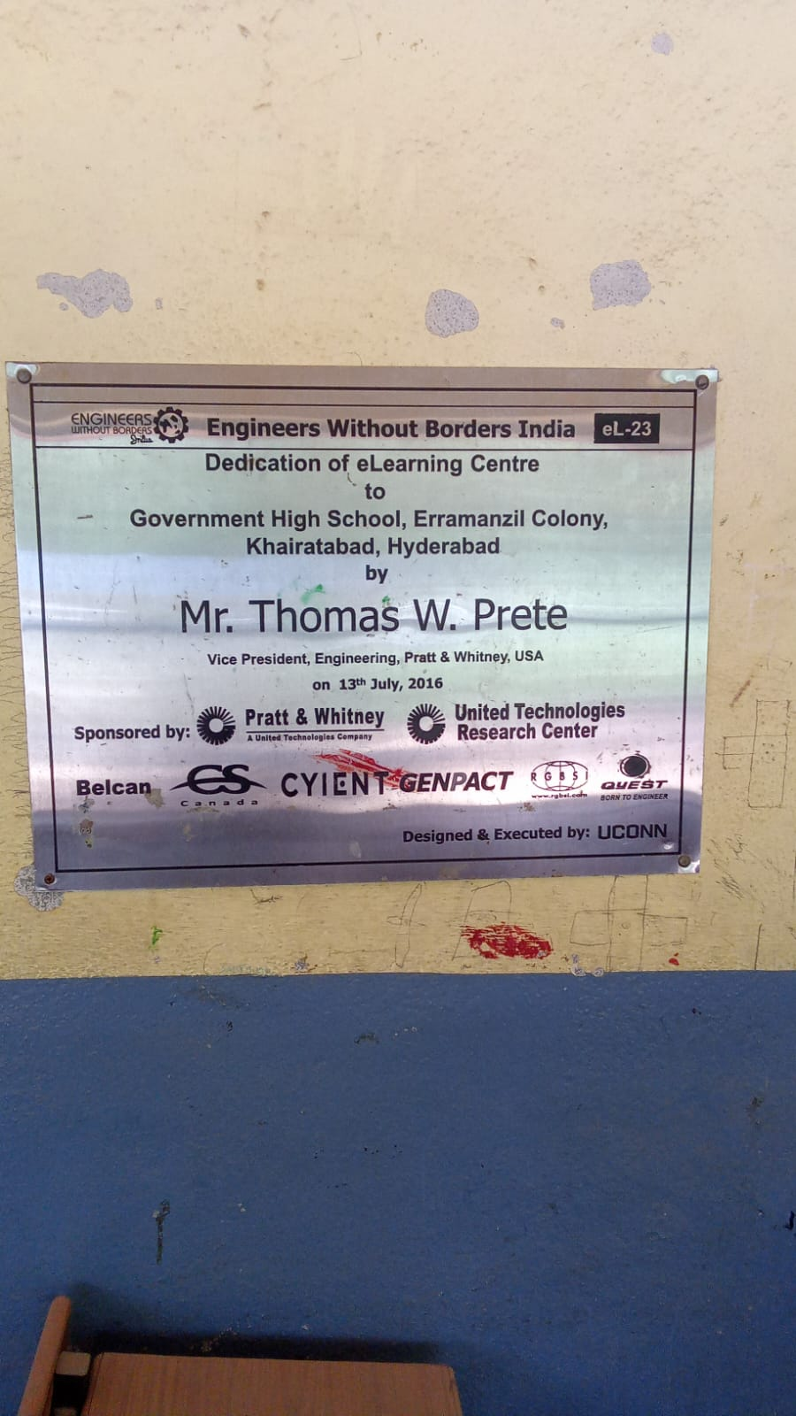  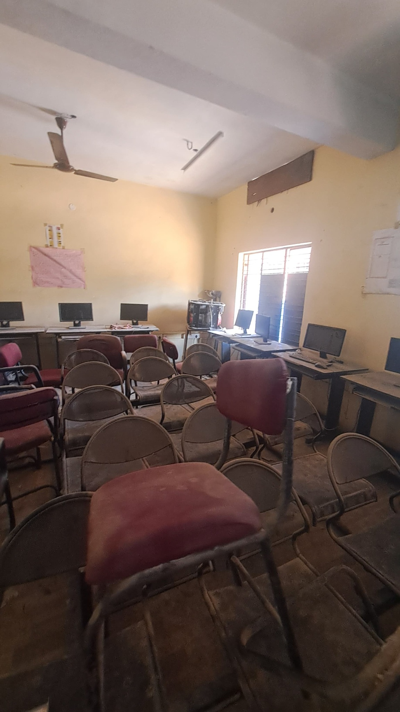  Plaque showing dedication of e-learning center. | 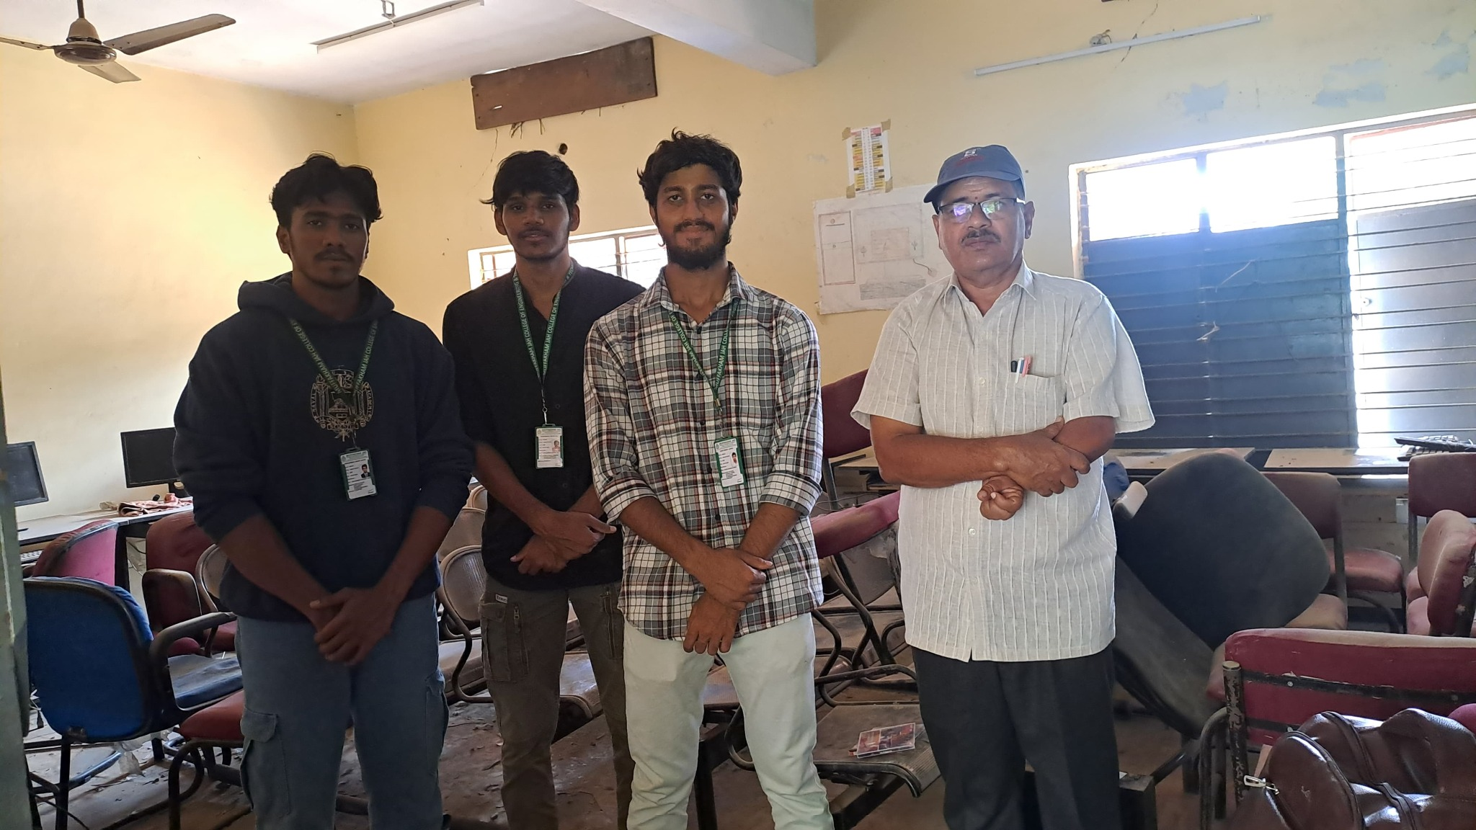  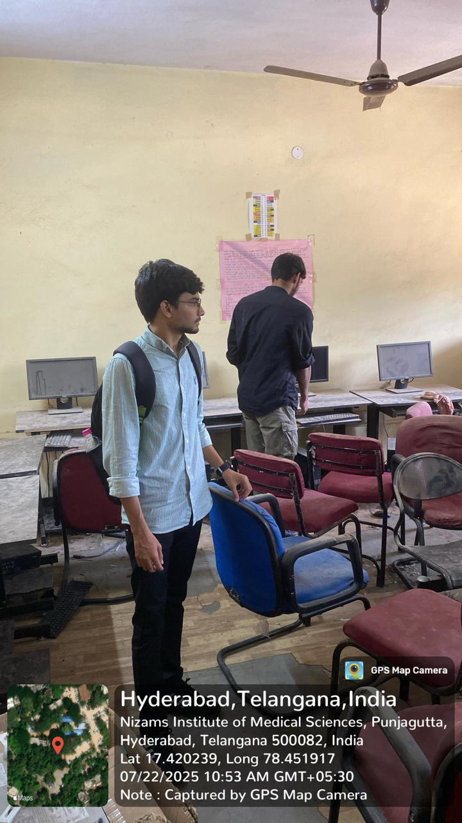  Inside the e-learning room.  Team assessing monitors and lab setup
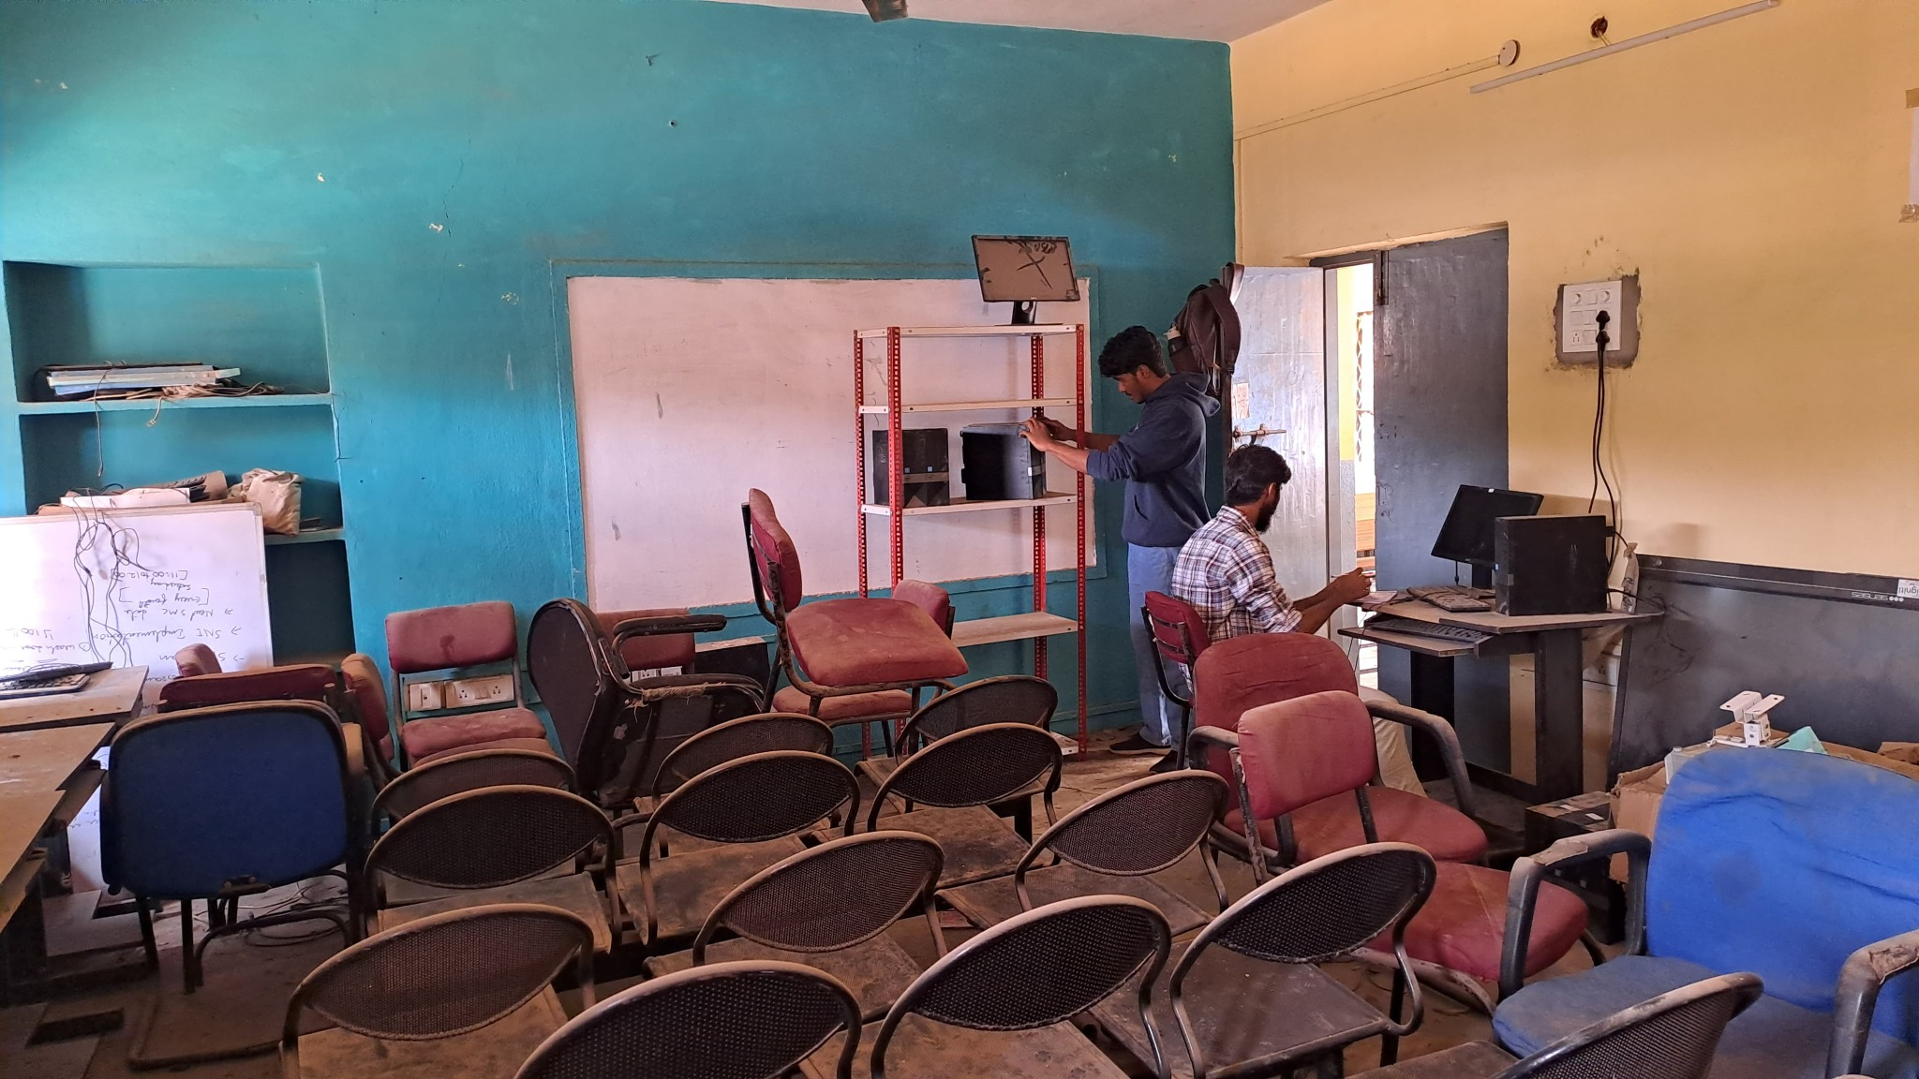  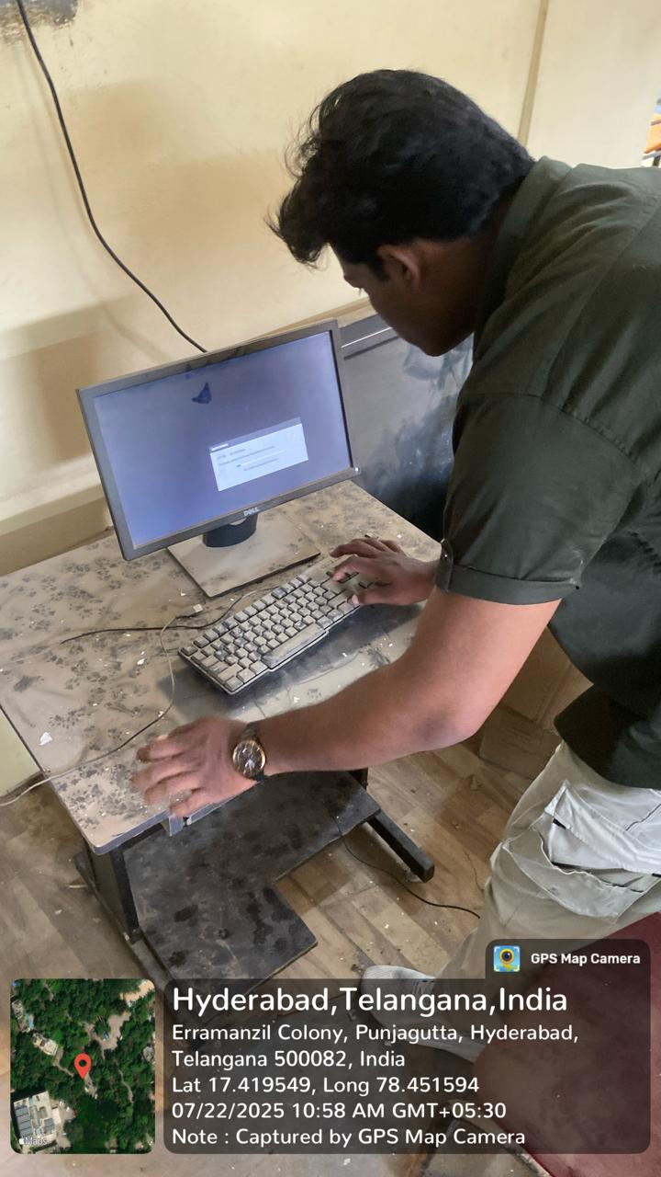  CPU boot check during inspection. | 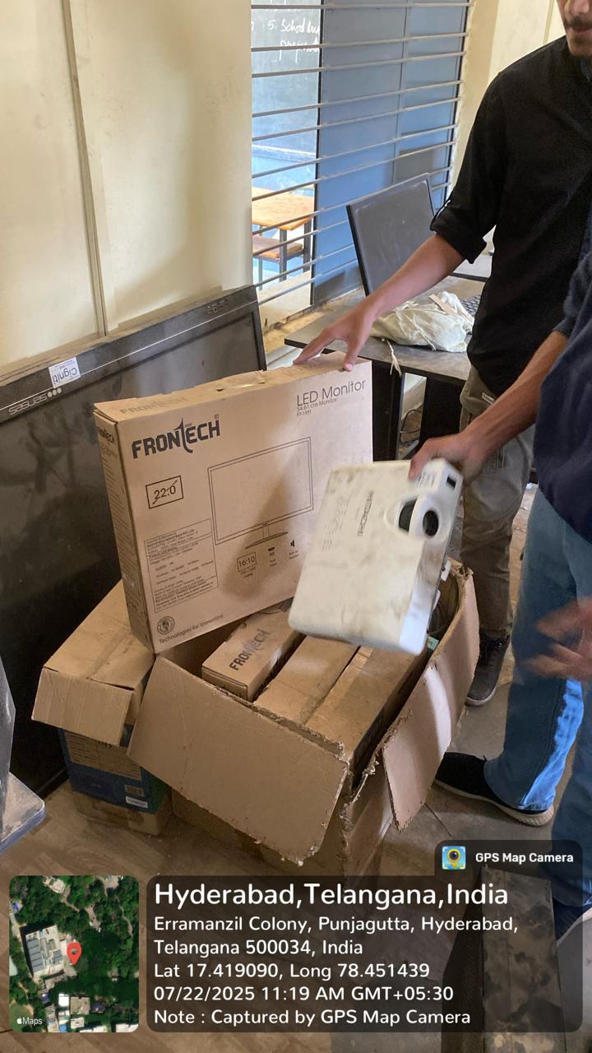  Inspection with tagged location and timestamp.  .  E-Learning class room PRESENT condition
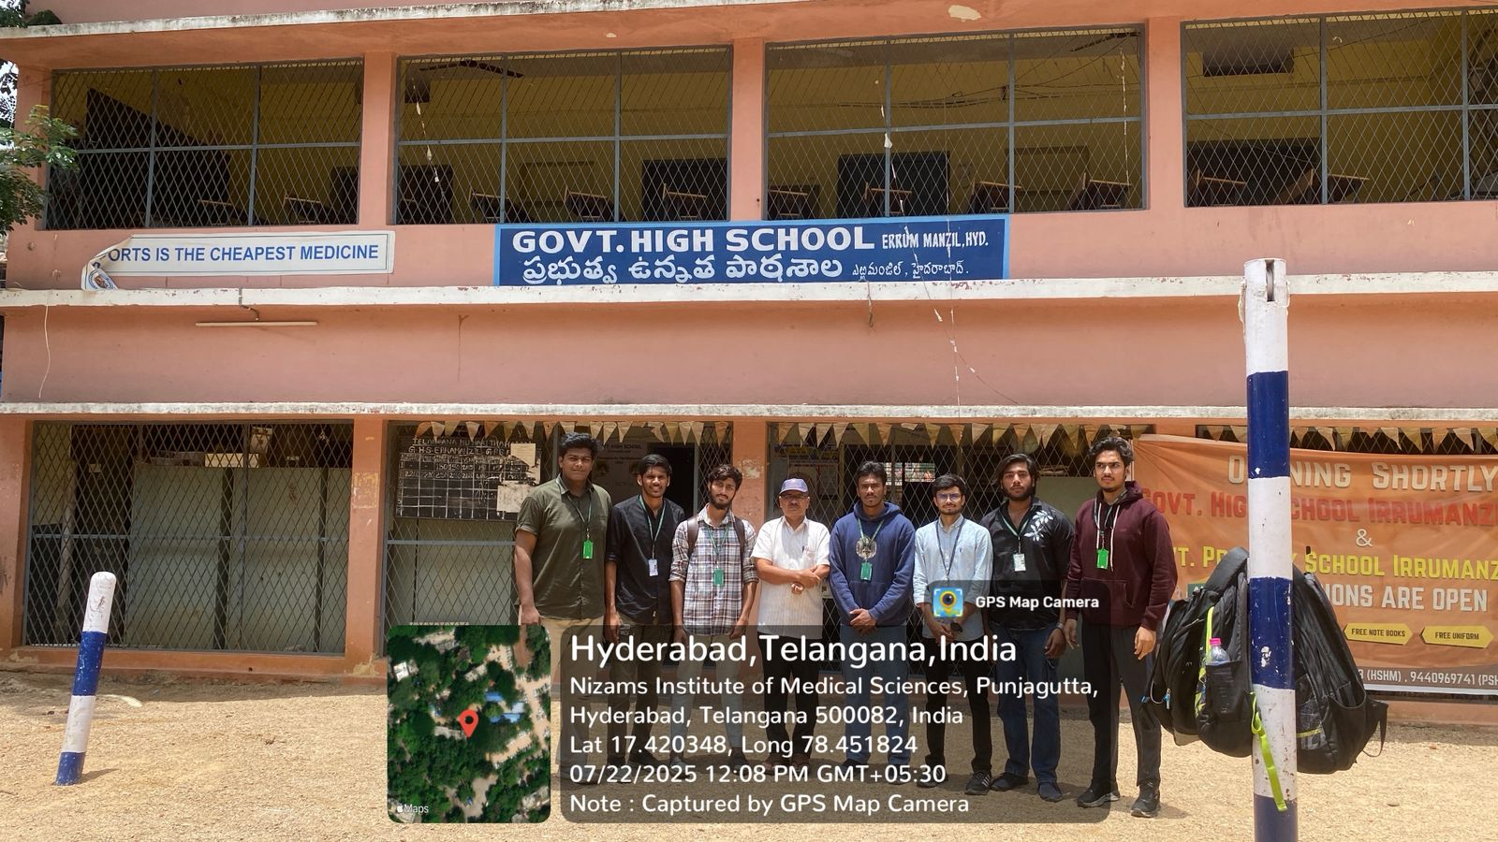

- RED CROSS HIGH SCHOOL, MASABTANK

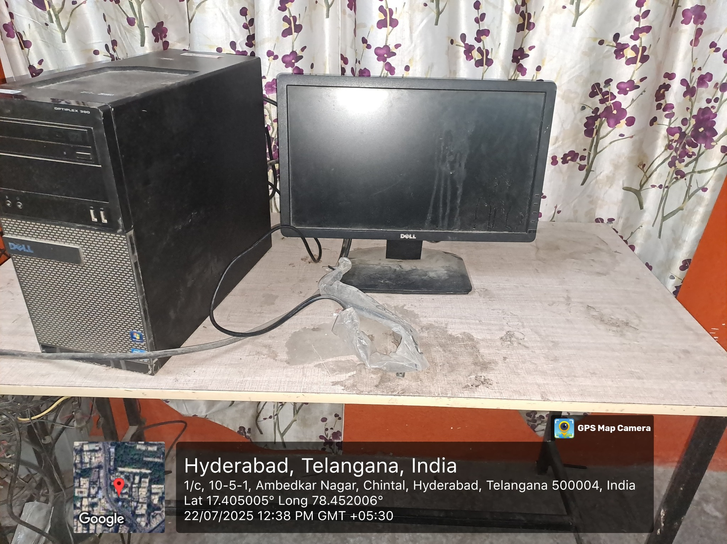
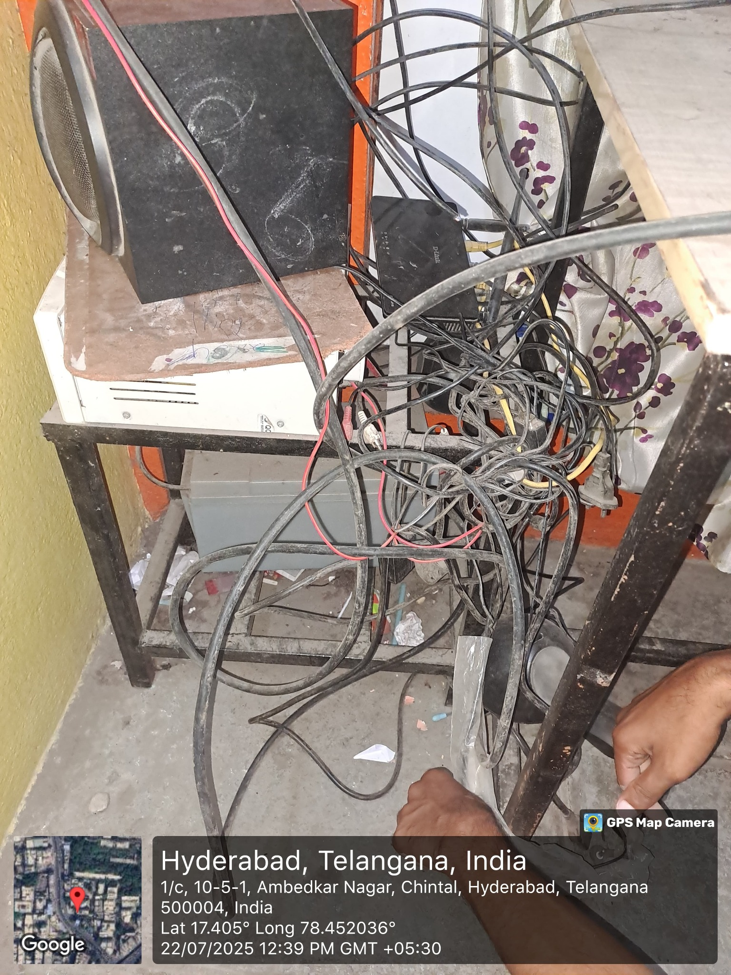
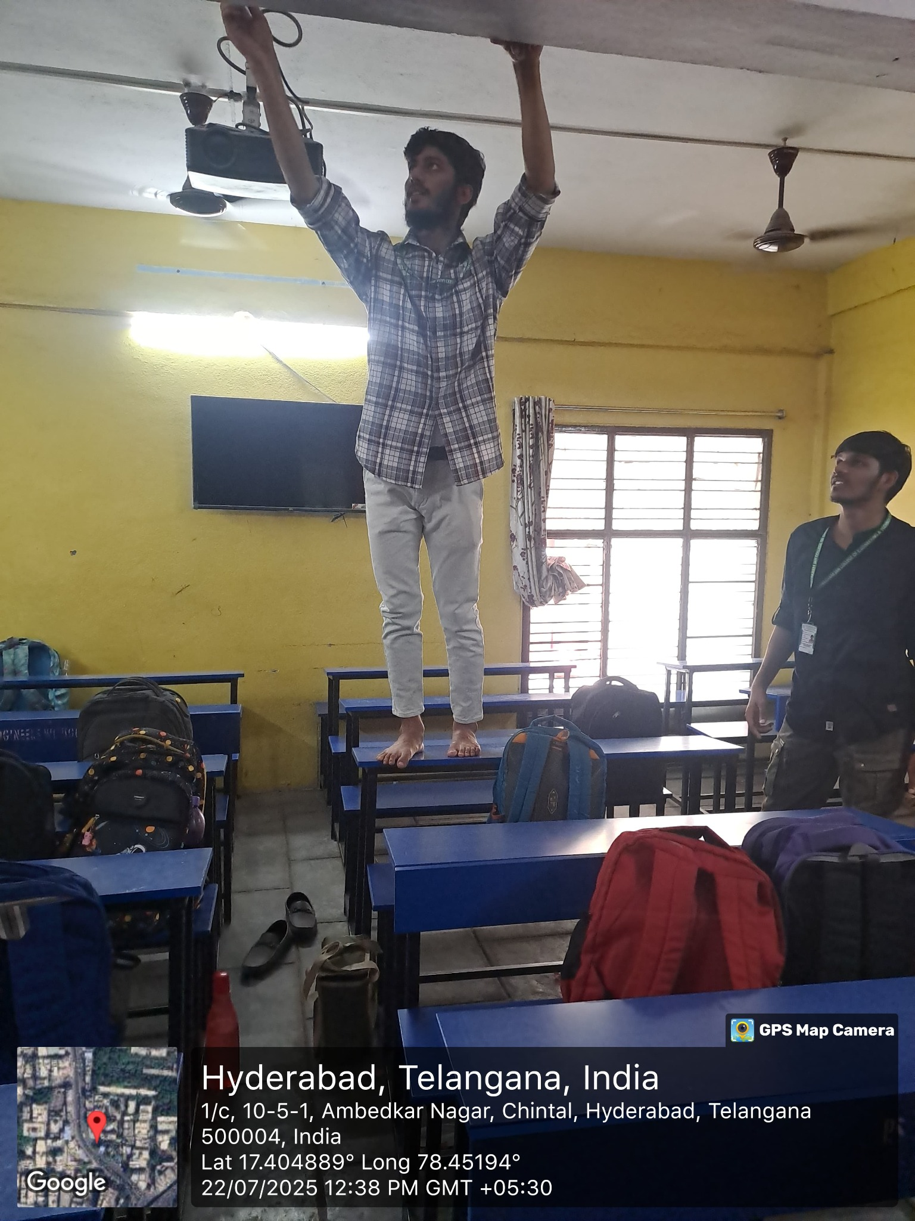
- Checking the working of projector
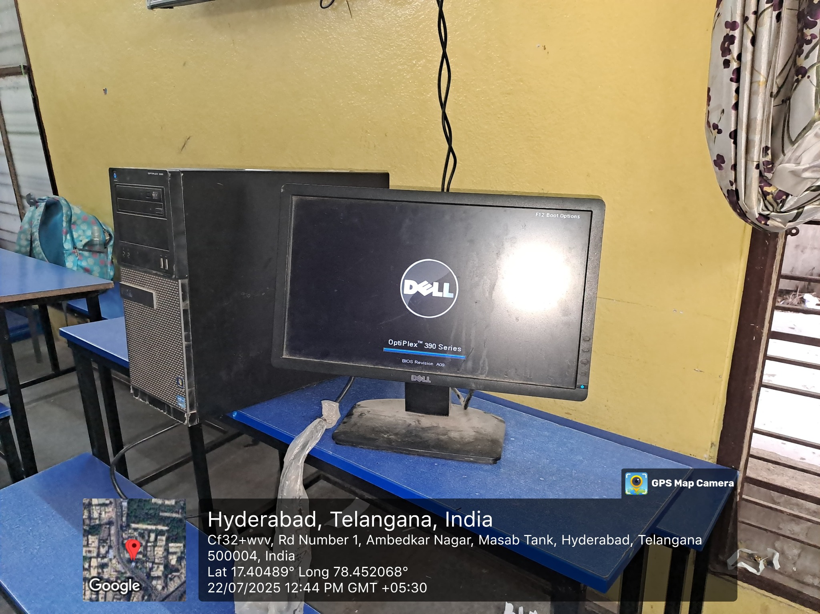
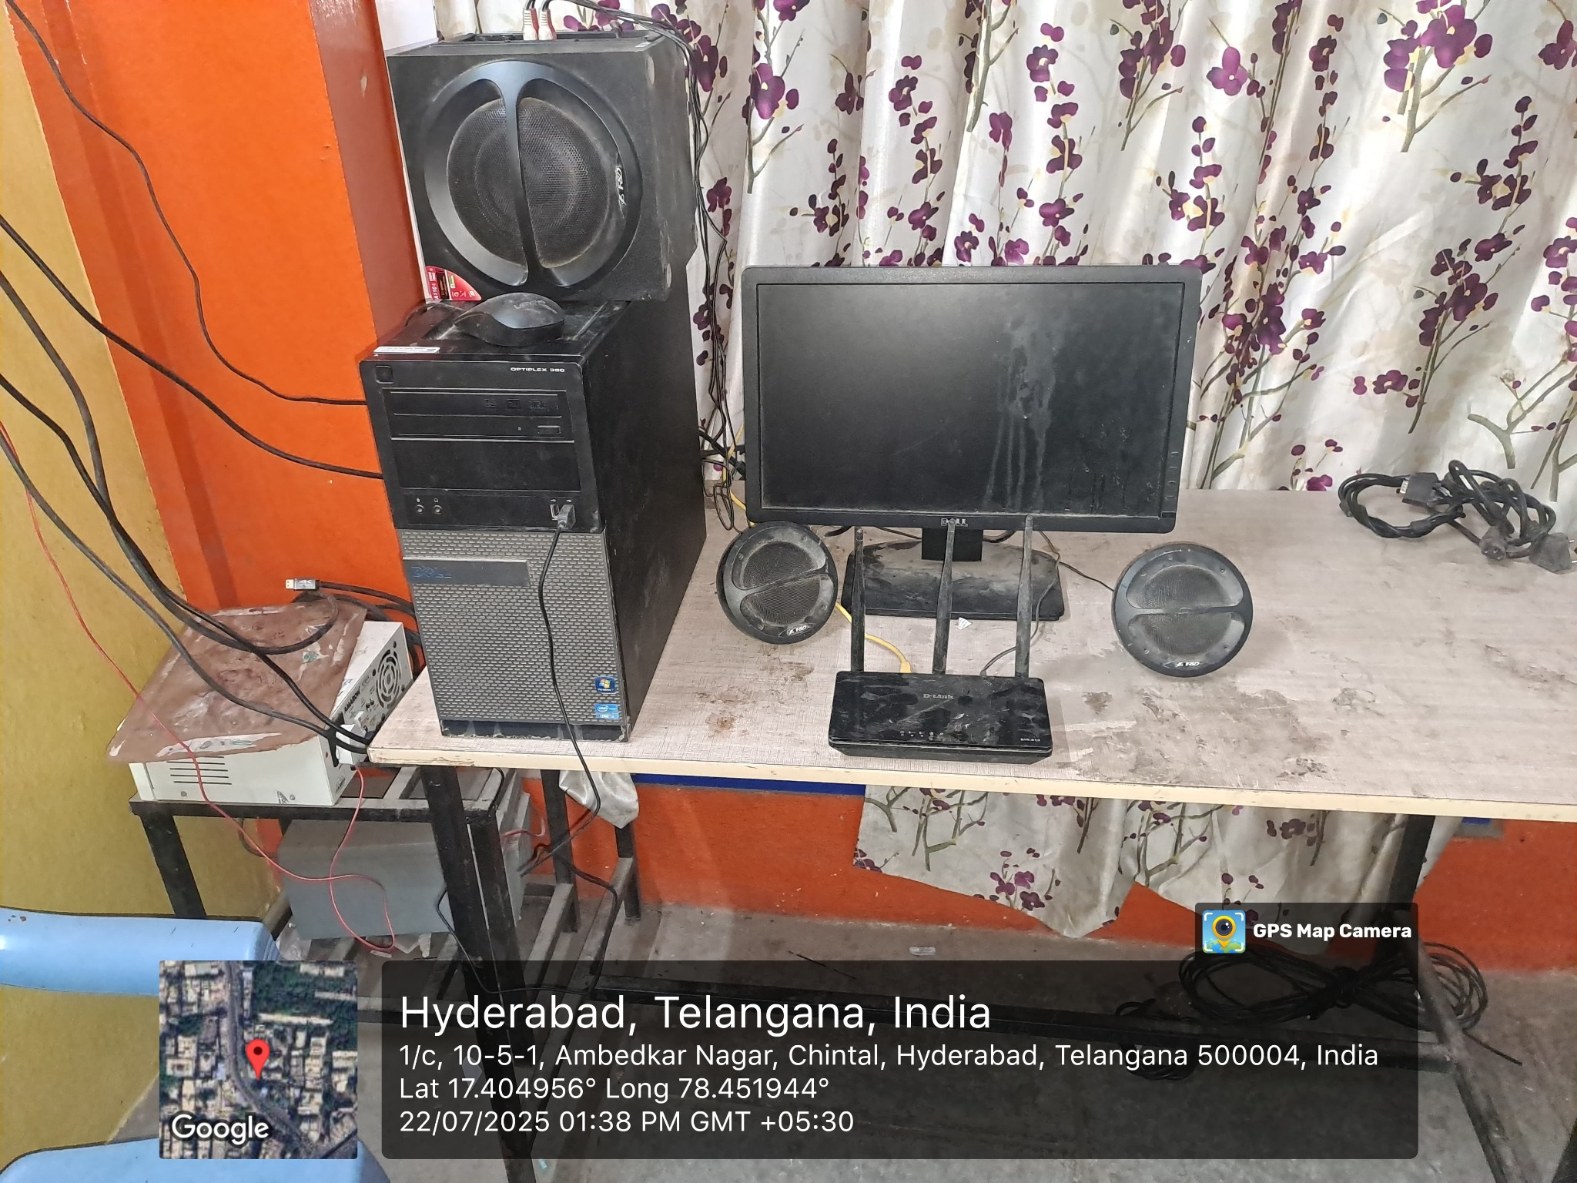
- Checking the working of computer
